Unit 1. Number Systems, Evolution, Block Diagram and Generations
Electronic and digital systems use various number systems such as Decimal, Binary, Hexadecimal and Octal, which are essential in computing.
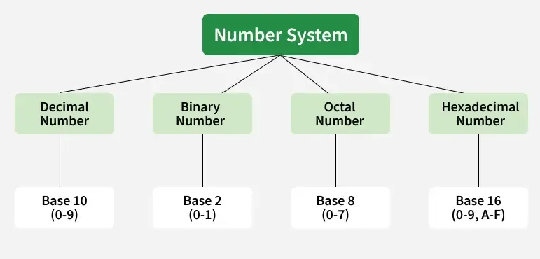

Types of Number System
There are four common types of number systems based on the radix or base of the number:

1. Decimal Number System
- The Decimal system is a base-10 number system.
- It uses ten digits: 0, 1, 2, 3, 4, 5, 6, 7, 8 and 9.
- Each digit’s place value is a power of 10 (e.g., 100, 101, 102).
- It is the standard system for everyday counting and calculations.

2. Binary Number System
- The Binary system is a base-2 number system.
- It uses two digits: 0 and 1.
- Each digit’s place value is a power of 2 (e.g., 20, 21, 22).
- The Binary system is the foundation for data representation in computers and digital electronics.

3. Octal Number System
- The Octal system is a base-8 number system.
- It uses eight digits: 0, 1, 2, 3, 4, 5, 6 and 7.
- Each digit’s place value is a power of 8 (e.g., 80, 81, 82).
- It is often used to simplify the representation of binary numbers by grouping them into sets of three bits.

4. Hexadecimal Number System
- The Hexadecimal system is a base-16 number system.
- It uses sixteen digits: 0, 1, 2, 3, 4, 5, 6, 7, 8, 9, A, B, C, D, E and F (where A = 10, B = 11, etc.).
- Each digit’s place value is a power of 16 (e.g., 160, 161, 162).
- Hexadecimal simplifies binary by representing every 4 bits as one digit (0-F).

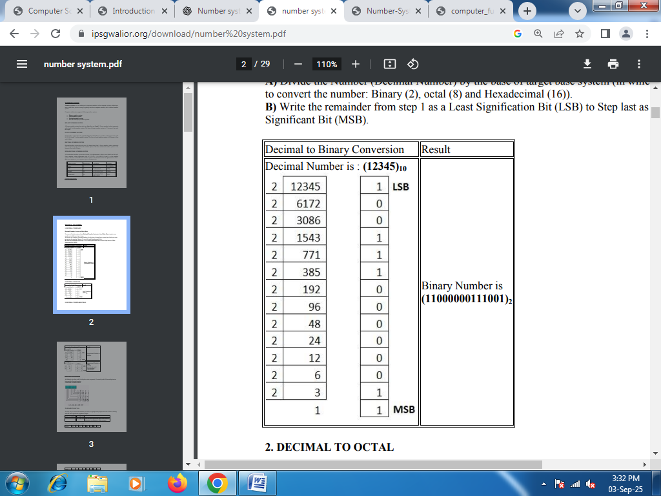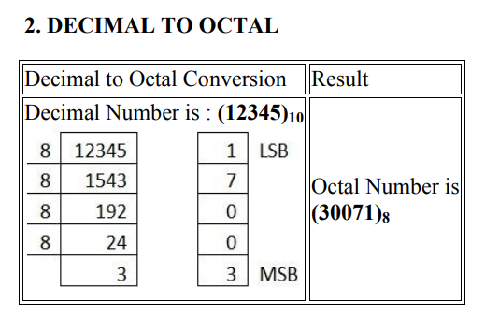
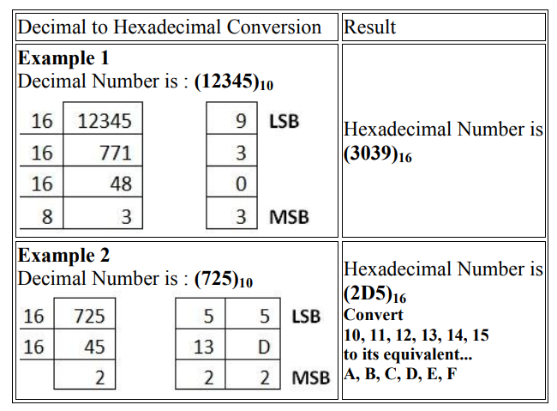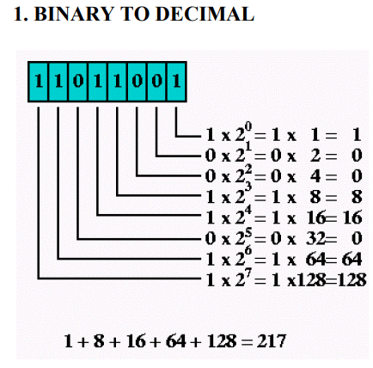
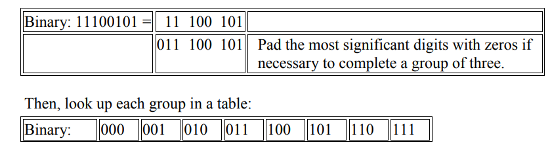
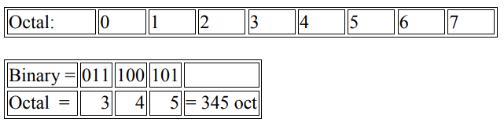
Fig. Binary to Octal conversion
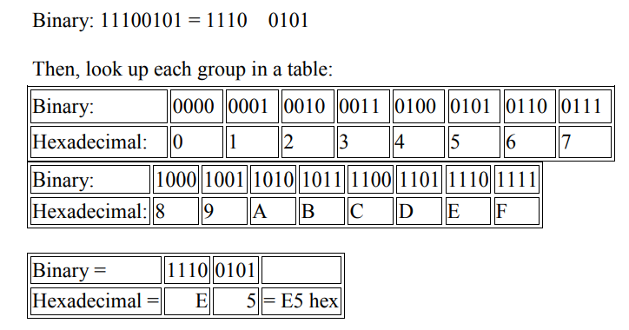
Fig.Binary to hexa decimal conversion
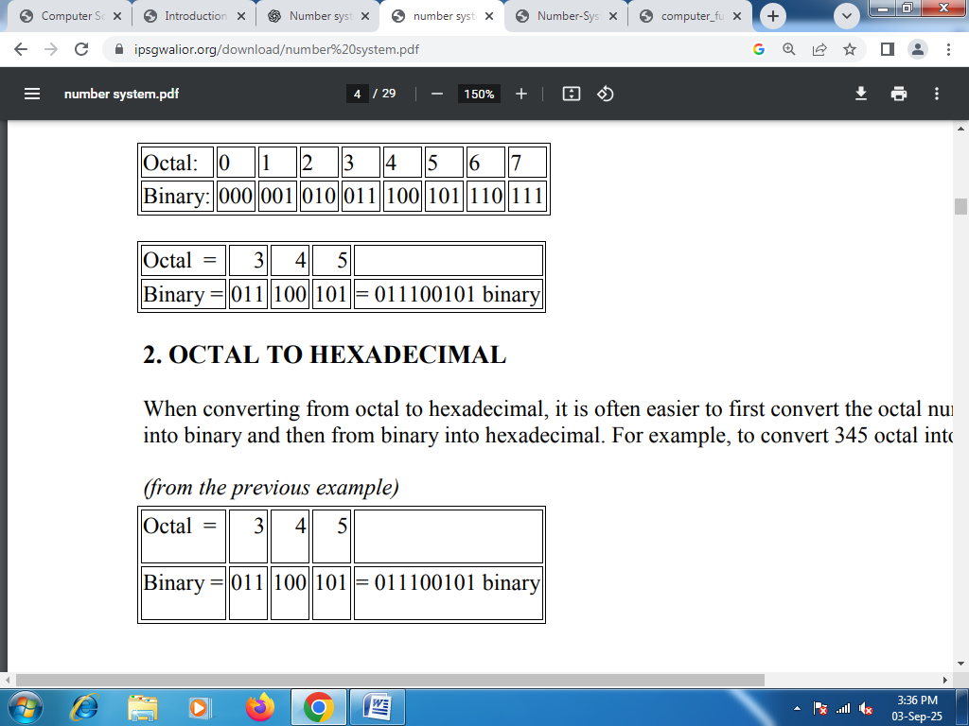
Fig.Octal to binary conversion
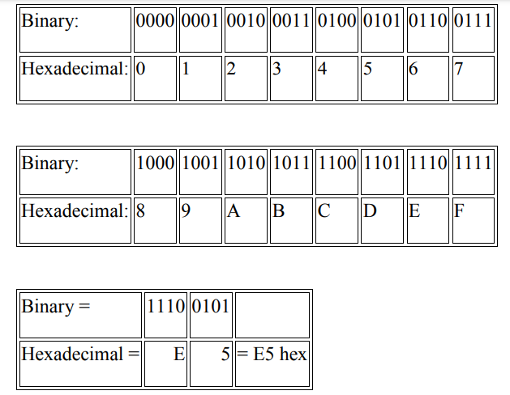
Fig.Binary to hexa decimal conversion
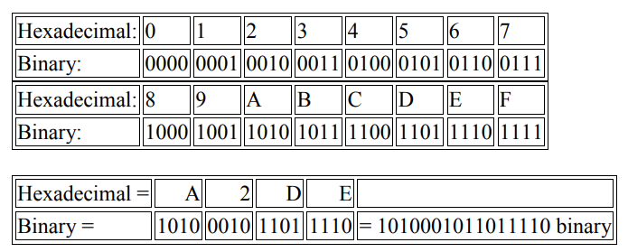
Fig.Hexa decimal to binary conversion
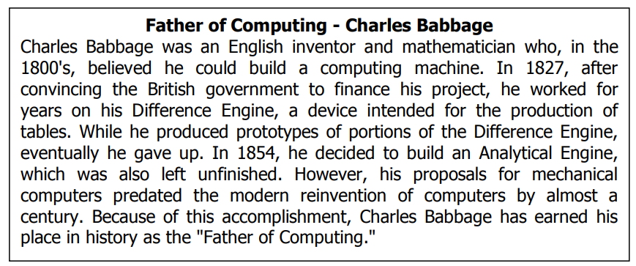

Early Mechanical Devices
- Abacus (3000 BC, China): First known device for arithmetic.
- Napier’s Bones (1617, John Napier): Wooden rods for multiplication/division.
- Pascaline (1642, Blaise Pascal): First mechanical calculator (addition/subtraction).
- Leibniz Calculator (1673, Gottfried Leibniz): Could multiply, divide, and find square roots.
- Jacquard’s Loom (1801, Joseph Jacquard): Used punched cards to control weaving → concept used in computers.
- Difference Engine (1822, Charles Babbage): Mechanical calculator for polynomials.
- Analytical Engine (1837, Charles Babbage): First design of a general-purpose computer.
  - Ada Lovelace: First computer programmer, wrote algorithms.
- Hollerith’s Tabulating Machine (1890, Herman Hollerith): Used punch cards for U.S. census → foundation of IBM.
Generations of Computers
The history of computer development is often referred to in reference to the different generations of computing devices. Each generation of computer is characterized by a major technological development that fundamentally changed the way computers operate, resulting in increasingly smaller, cheaper, more powerful, efficient and reliable devices.
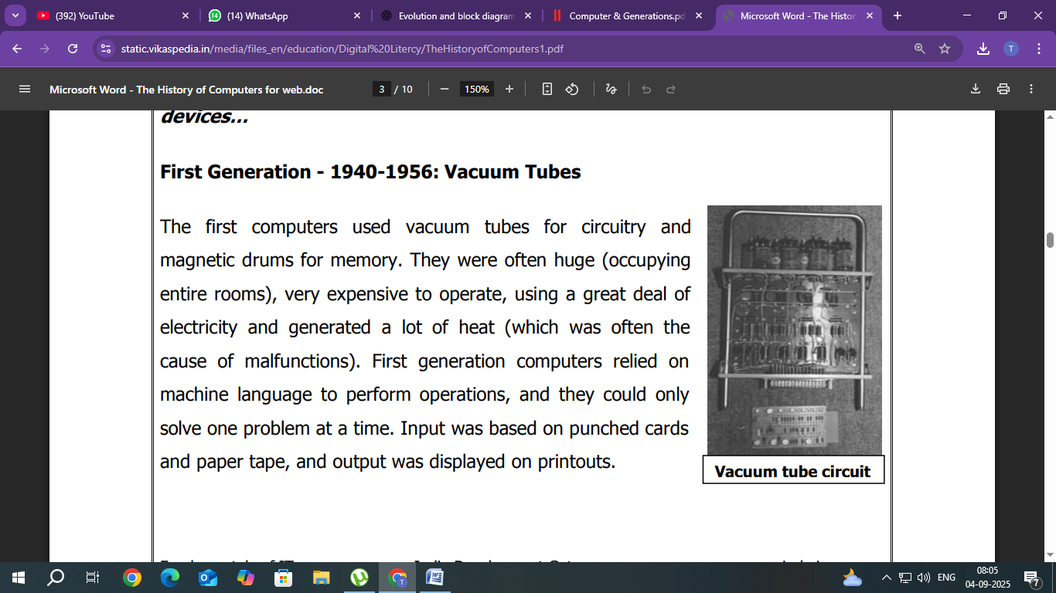
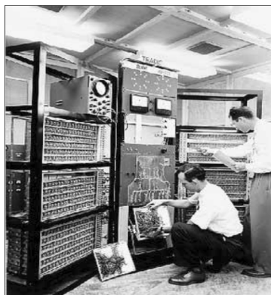
The main features of the first generation are:
  - Vacuum tube technology
  - Unreliable
  - Supported machine language only
  - Very costly
  - Generates lot of heat
  - Slow input and output devices
  - Huge size
  - Need of AC
  - Non-portable
  - Consumes lot of electricity
Some computers of this generation were:
  - ENIAC
  - EDVAC
  - UNIVAC
  - IBM-701
  - IBM-750
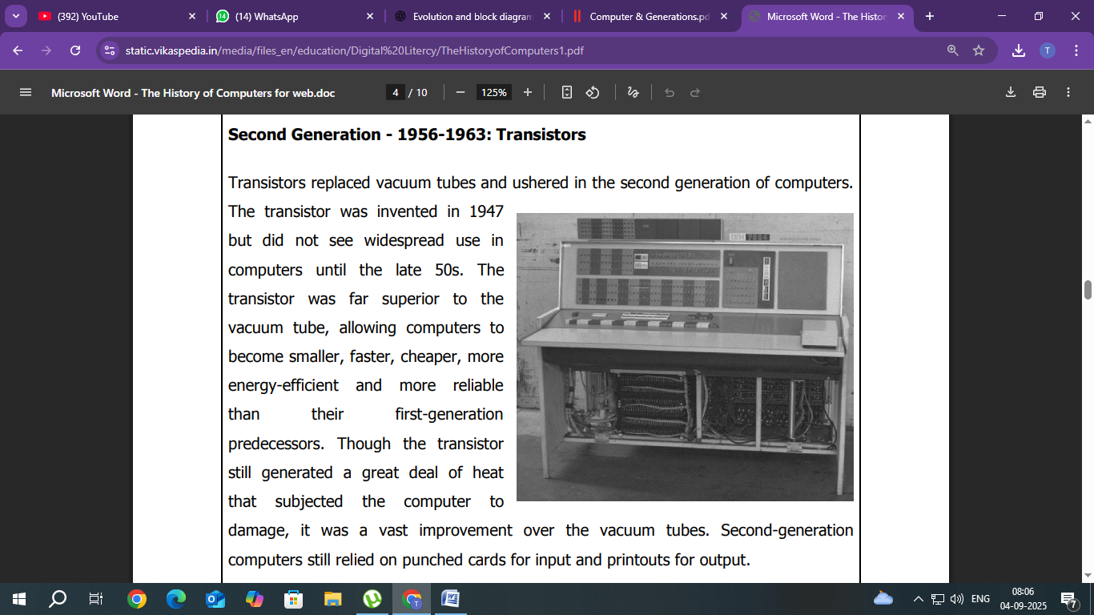
The main features of second generation are:
- Use of transistors
- Reliable in comparison to first generation computers
- Smaller size as compared to first generation computers
- Generates less heat as compared to first generation computers
- Consumed less electricity as compared to first generation computers
- Faster than first generation computers
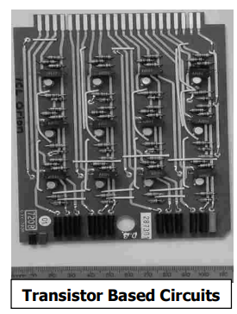
- Still very costly
- AC required
- Supported machine and assembly languages
Some computers of this generation were:
  - IBM 1620
  - IBM 7094
  - CDC 1604
  - CDC 3600
  - UNIVAC 1108
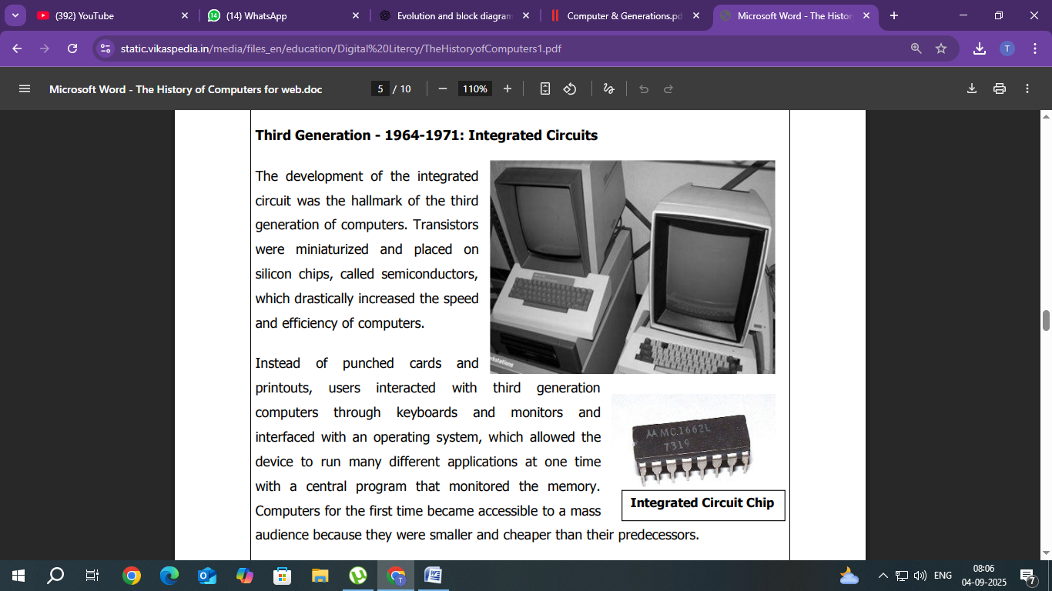
The main features of third generation are:
  - IC used
  - More reliable in comparison to previous two generations
  - Smaller size
  - Generated less heat
  - Faster
  - Lesser maintenance
  - Costly
  - AC required
  - Consumed lesser electricity
  - Supported high-level language
Some computers of this generation were:
  - IBM-360 series
  - Honeywell-6000 series
  - PDP (Personal Data Processor)
  - IBM-370/168
  - TDC-316
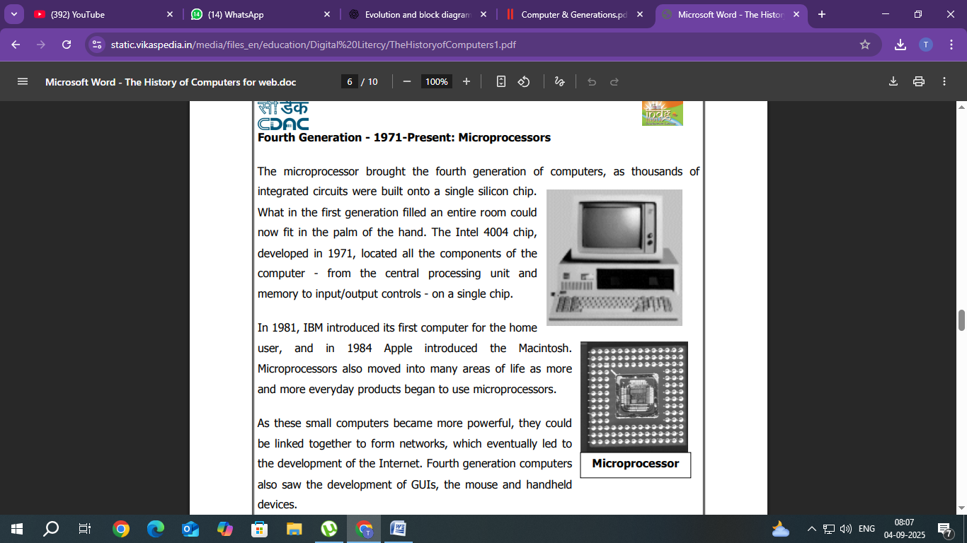
The main features of fourth generation are:
  - VLSI technology used
  - Very cheap
  - Portable and reliable
  - Use of PCs
  - Very small size
  - Pipeline processing
  - No AC required
  - Concept of internet was introduced
  - Great developments in the fields of networks
  - Computers became easily available
Some computers of this generation were:
  - DEC 10
  - STAR 1000
  - PDP 11
  - CRAY-1(Super Computer)
  - CRAY-X-MP(Super Computer
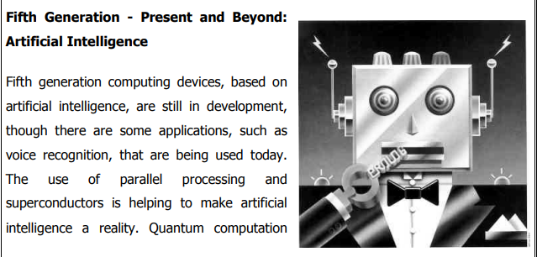
The main features of fifth generation are:
- ULSI technology
- Development of true artificial intelligence
- Development of Natural language processing
- Advancement in Parallel Processing
- Advancement in Superconductor technology
- More user-friendly interfaces with multimedia features
- Availability of very powerful and compact computers at cheaper rates
Some computer types of this generation are:
  - Desktop
  - Laptop
  - Notebook
  - Ultrabook
  - Chromebook

Block Diagram of Computer
A block diagram of a computer shows its main parts and how they work together. It makes it easy to understand how data moves between the CPU, memory, input/output devices, and storage.

The components in a block diagram of a computer typically include:
- Input Unit – Devices like a keyboard and a mouse that send data to the computer.
- Central Processing Unit (CPU) – The brain that processes data, including:
  - Arithmetic Logic Unit (ALU) – Performs calculations and logical operations.
  - Control Unit (CU) – Manages data flow and instructions.
- Memory Unit – Stores data and instructions, including:
  - Primary Memory (RAM) – Temporary storage for active processes.
  - Secondary Memory (HDD/SSD) – Permanent storage for data.
- Output Unit – Devices like monitors and printers that display or produce results.
These components are connected to show data flow (input → CPU → memory → output).

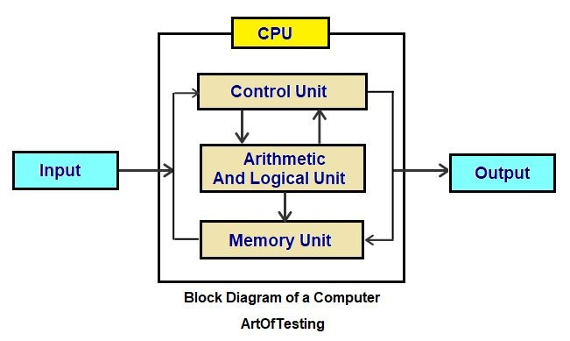
- The data is accepted by the input unit. It is given by the user. It is then converted into binary form for the computer to read it.
- The information is then sent to the memory unit for storage and processing.
- The required data, that needs to be processed is accessed by the CPU. It is accessed from the primary storage. The arithmetic and logical operations are then performed on the data. The control unit schedules all the activities for the smooth working of the computer.
- The data is then sent to the storage unit. It is used for storing or further processing purposes.

- Then the output unit receives the final processed output.

